Ethical Hacking
LAB
1. Execute and display the results for the following commands in Kali Linux Operating
Systems
rm command
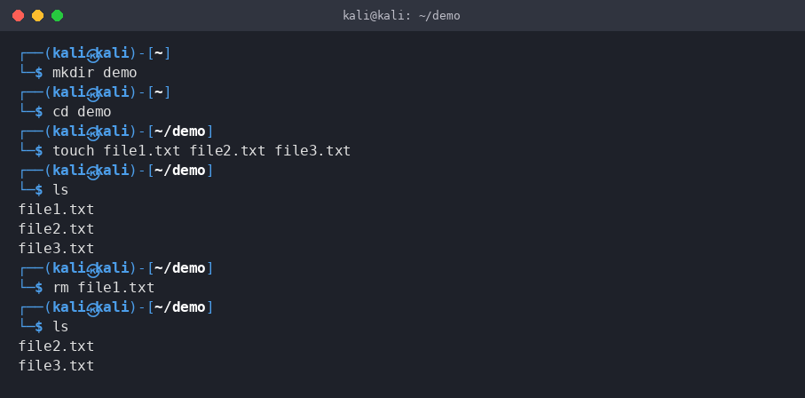
users command
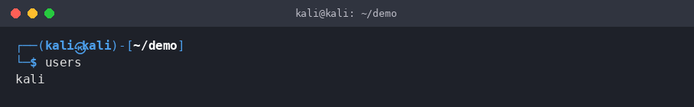
tree command
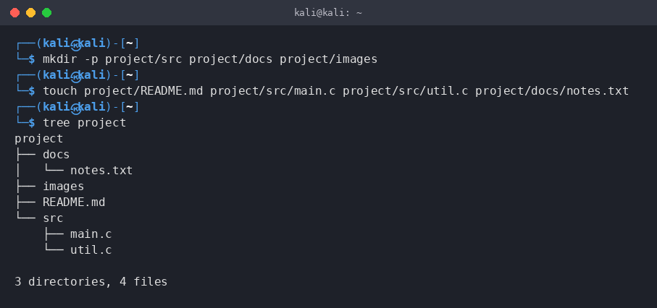

2. Execute and display the results for the following commands in Kali Linux Operating
Systems:

less command
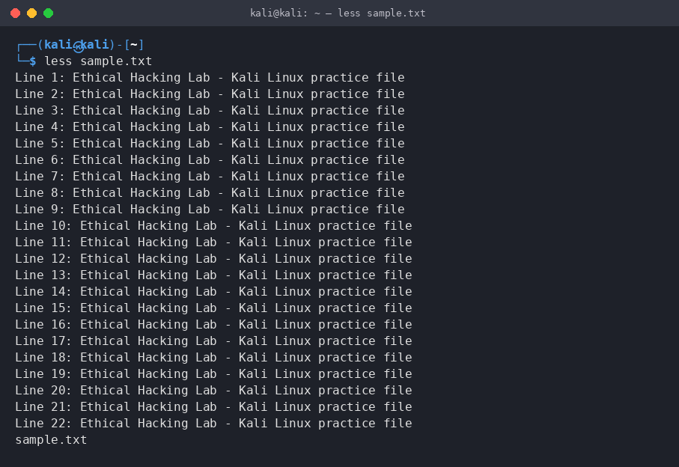
more command
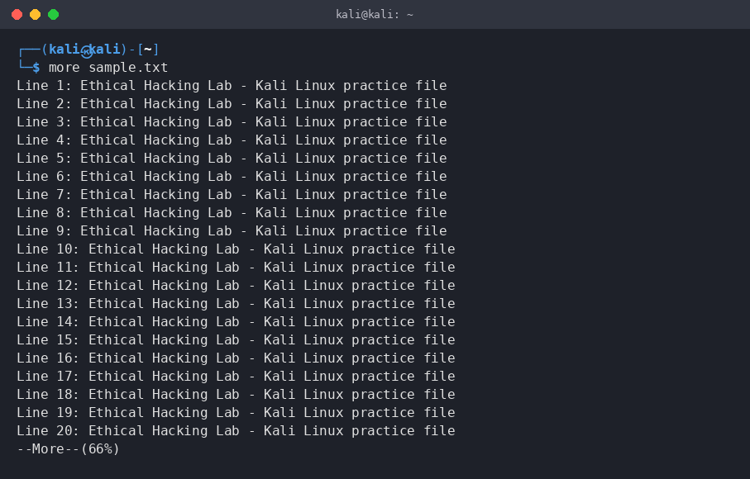
vi command
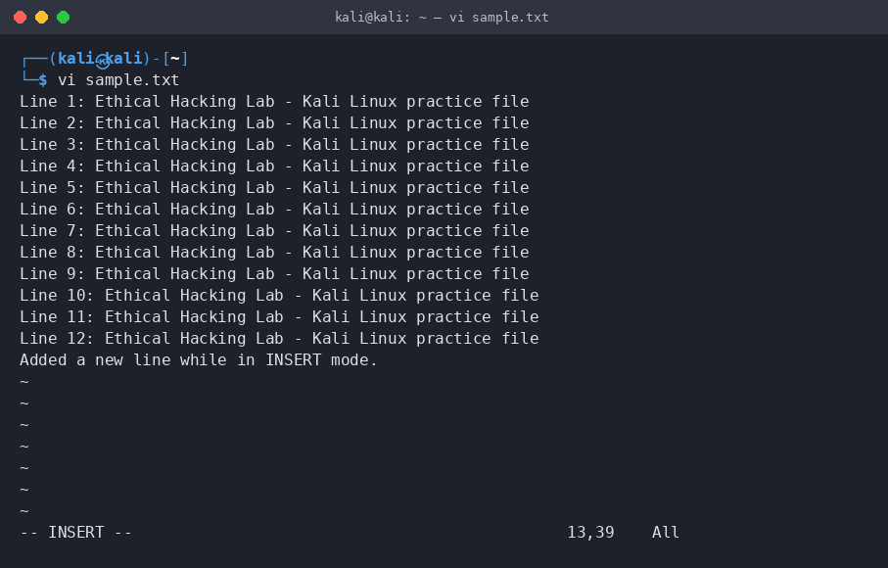
3. Execute and display the results for the following commands in Kali Linux Operating
Systems:

Tree
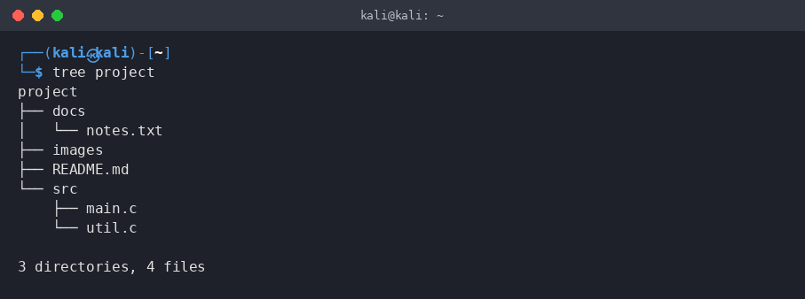
Head
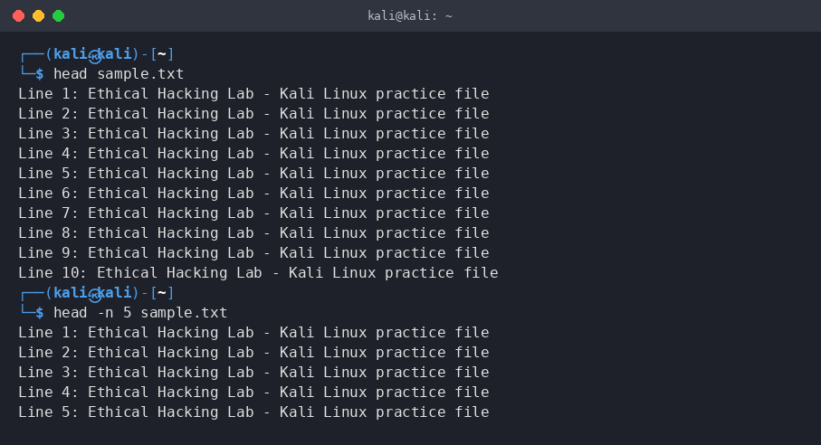
Tail
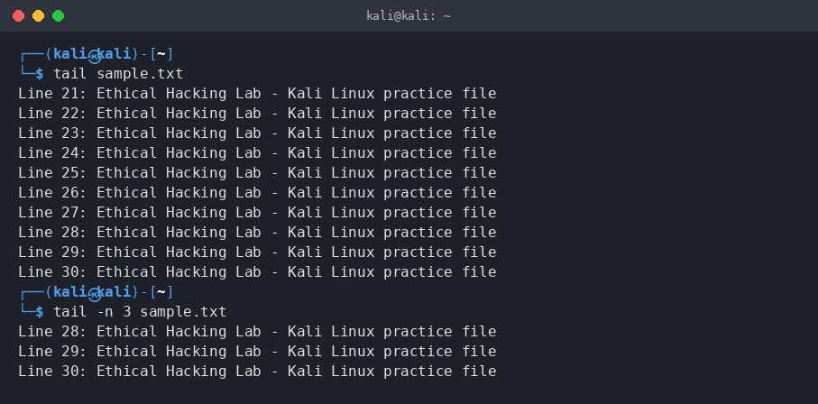

4. Execute and display the results for the following commands in Kali Linux Operating
Systems:

- Ls
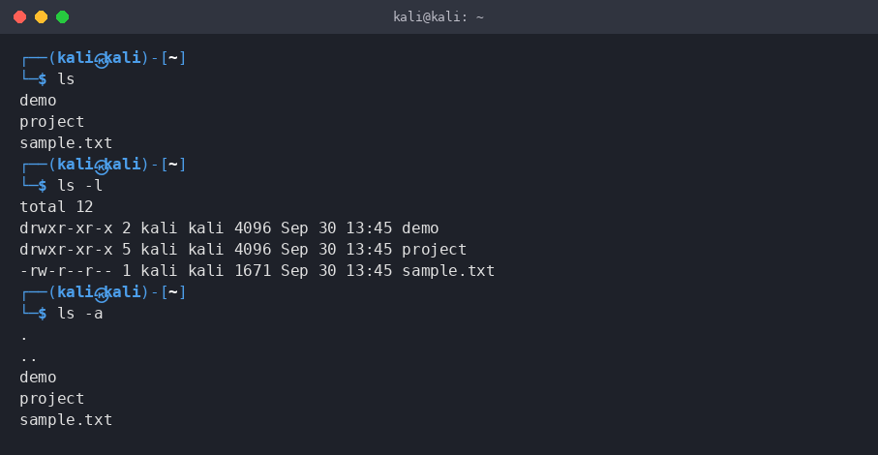
- Cat
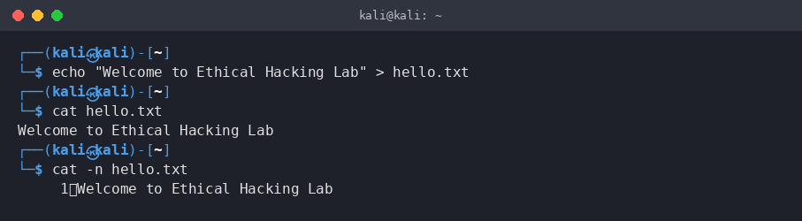
- Mkdir
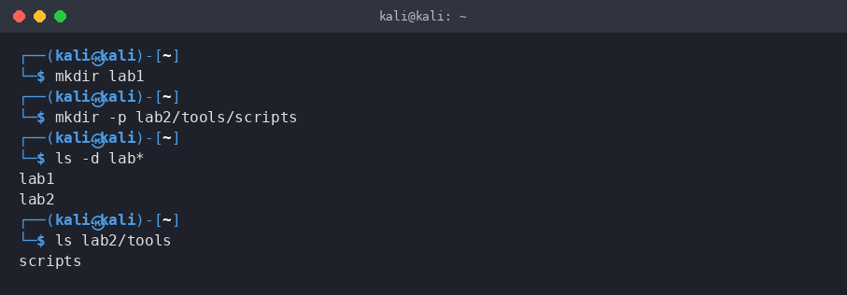

5. Execute and display the results for the following commands in Kali Linux Operating
Systems:

- Uptime
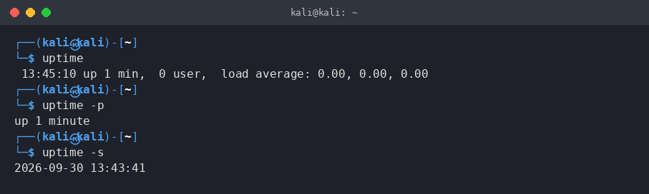
- Date
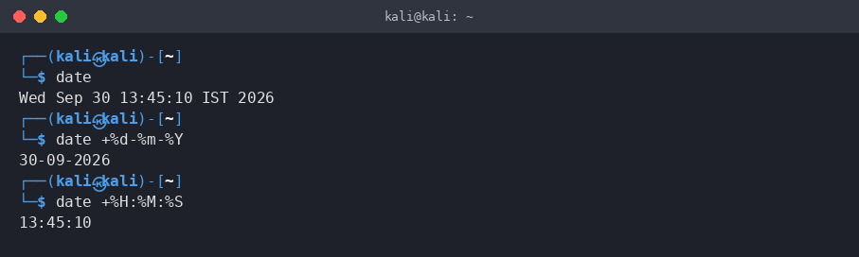
- Mv
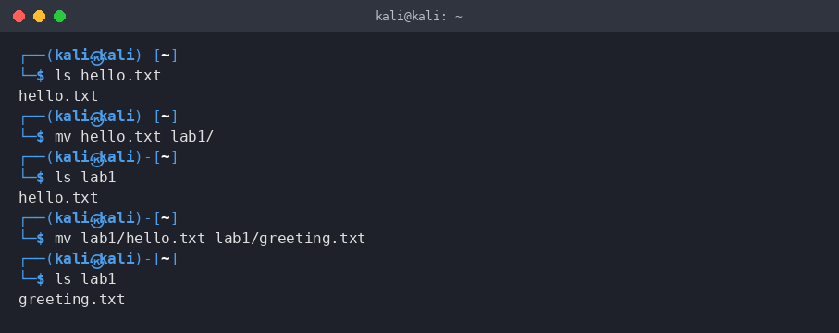

6. Execute and display the results for the following commands in Kali Linux Operating
Systems:
- Touch
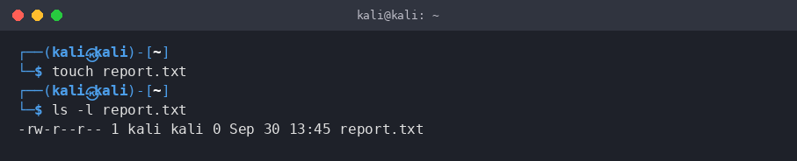
- Pwd
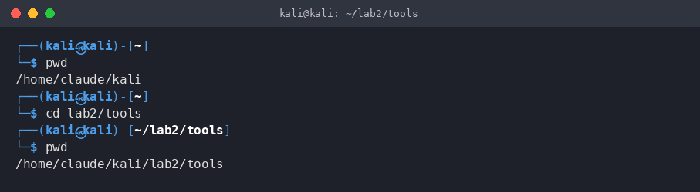
- Wget
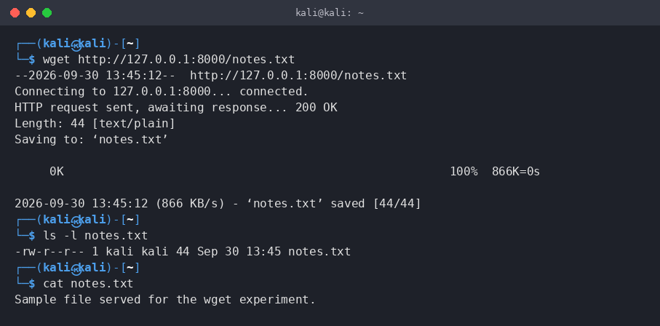

7. Execute and display the results for the following commands in Kali Linux Operating
Systems:
Cd
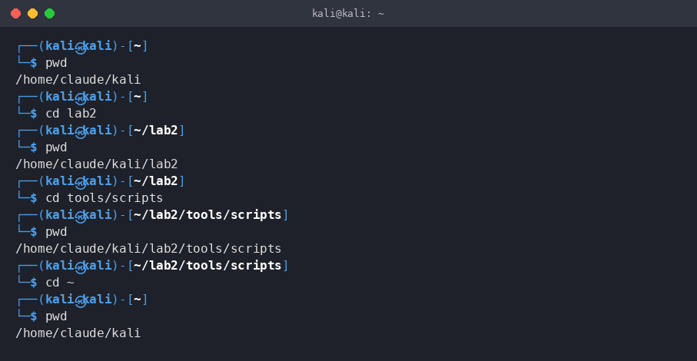
Cp
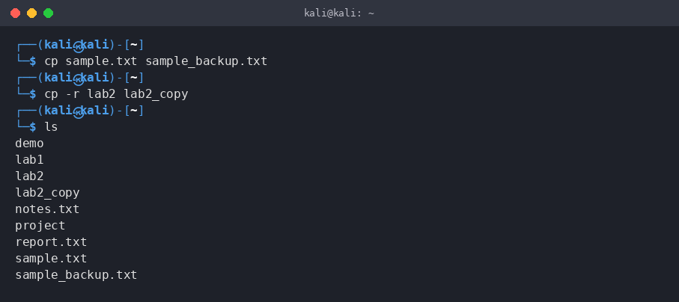
Ls
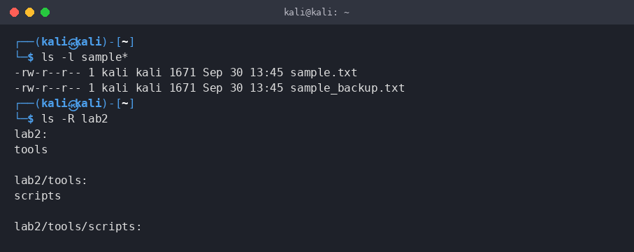
8. Execute and display the results for the following Nmap service version and OS
detection commands in Kali Linux operating systems:
- detect the version of services running
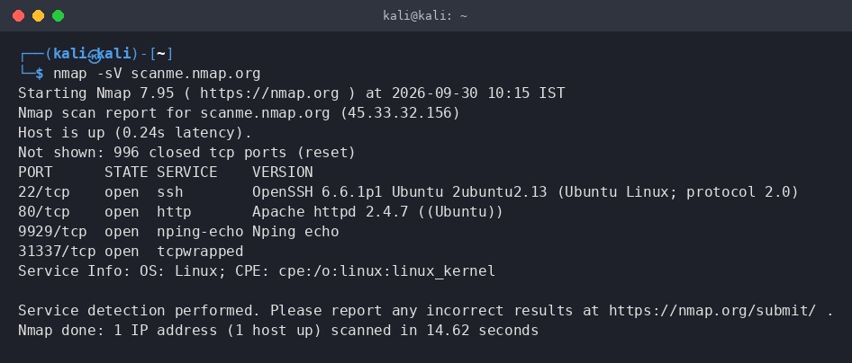
- aggressive scan
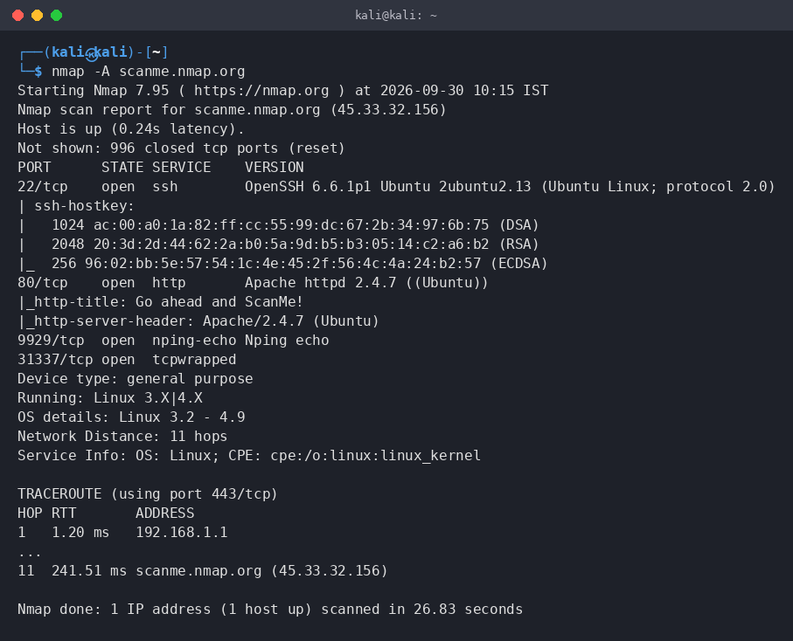
- detect operating system of the target
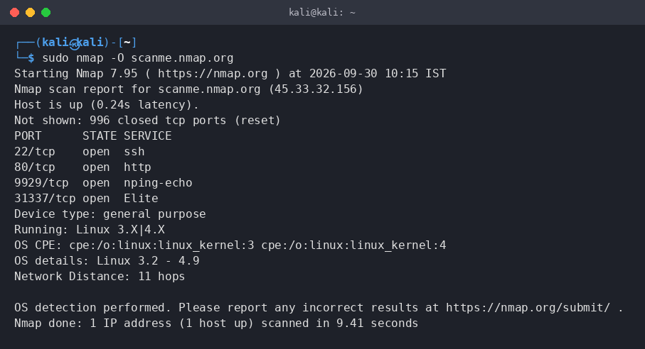
9. Execute and display the results for the following Nmap Timing and performance
commands in Kali Linux operating Systems:
- polite IDS evasion
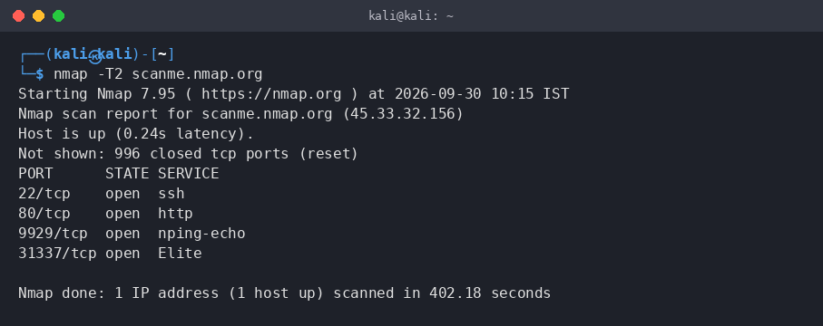
- normal IDS evasion
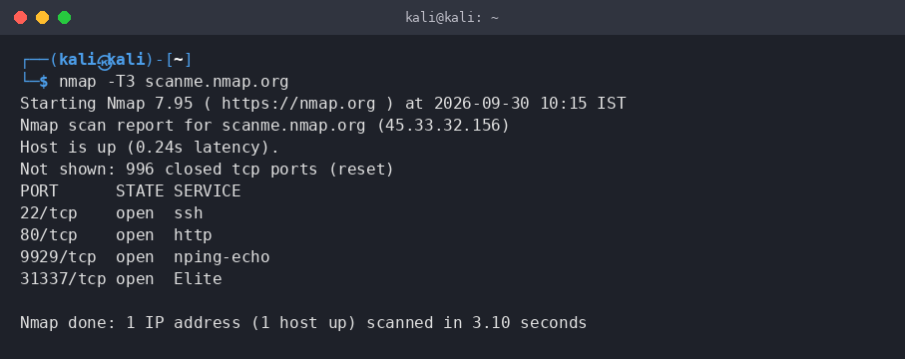

10. To execute the following commands in Kali Linux Operating Systems:
Free command
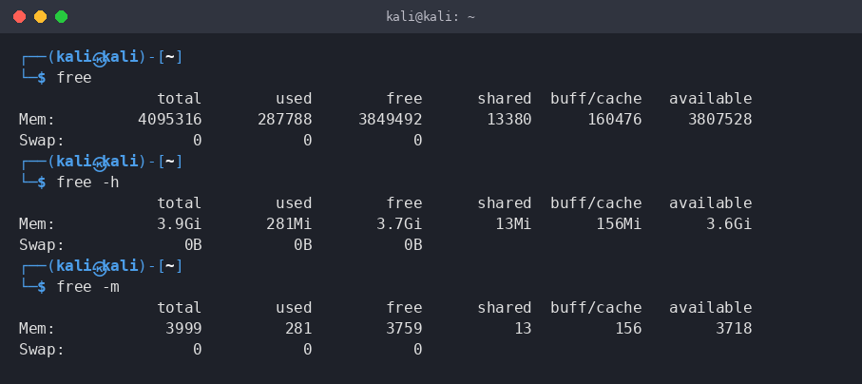
Sort command
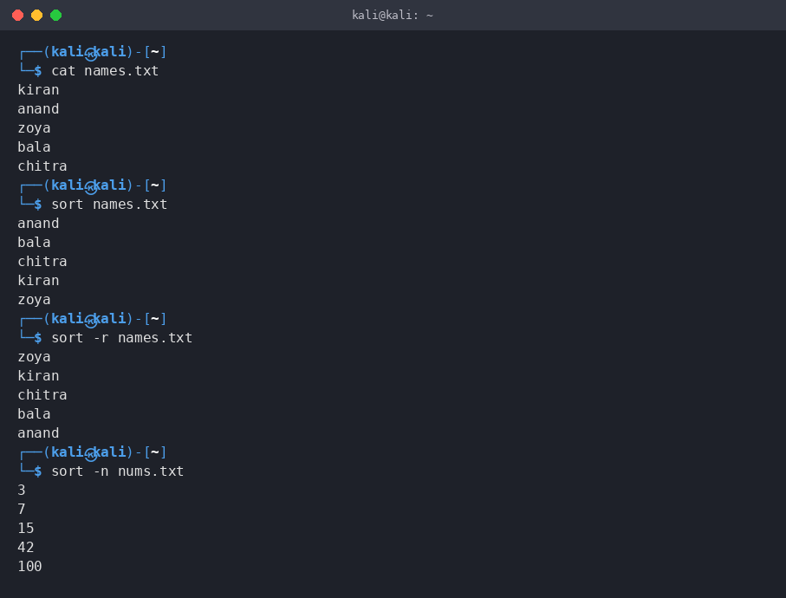
History command
